Soil-Net Content Protocols Steve Hallett 13/7/05

With some 50+ topics requiring content text, it is crucial to have a clear protocol for managing the process of the creation of the content for Soil-Net to avoid confusion and mistakes. It is proposed the following approach be adopted.

New document created: Peter Bullock creates a new topic file in MS Word. Each file has the following characteristics;

File name – Follows form “Section I i v2.doc” (allows folder of files to be sorted easily)
File Structure – Chapter Heading, Section Heading, Text, KS1 bullet points (max 10), and a Key Topic Learning point (one overarching topic statement/point)

Files are then uploaded to the Soil-Net Development-Content website section by Peter Bullock, and if necessary a blog entry created to inform the others. Recognising the complexity of this process, Peter Bullock can also submit the file by email to Steve Hallett for posting on website by proxy.

Documents edited and revised: A Soil-Net team member informs Peter Bullock of intent to edit and revise text;

File is downloaded from website by team member (right mouse, ‘save as’)
In MS Word, the ‘Track Changes’ feature is enabled
The edits are made as required
The file is saved to a new filename and the version number incremented, thus: “Section I i v3.doc”
The file is emailed to Peter Bullock who, having the ultimate editorial control chooses to accept or reject edits and to thereby formally accept the new document.
Once formally accepted, the new file version is uploaded to the Soil-Net website, thereby replacing the previous version.

The following Sections relate to the following activities:

Uploading a NEW file 2
Uploading an EDITED file 4
Editing textual content 5
Errors 6
Editing image labels 7

Uploading a NEW file
Login to Soil-Net using your username and password
Navigate to ‘Development’ -> ‘Content’
Select the menu option ‘Edit’ to enter editing mode

Scroll down the editor page to the section “userFiles for admin group Development” and select upload new file

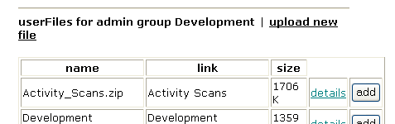

At “Upload a new userFile belonging to "Development"” menu, ‘Browse’ to locate the new file on your hard disk.

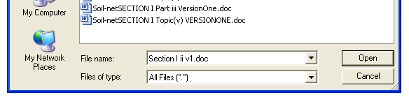

Now enter a name for the new user file that does NOT contain the version number (as this is a label which will be reused and reused) – e.g. “Section I ii”

Now enter some text for the link to the file that DOES contain the version number (as this text is associated with this specific file) – e.g. “Section I ii v1”

In total there will be three entries made as below – now select ‘Submit’ and then ‘Back to Page Editor’ (unless you are adding several files, in which case repeat).

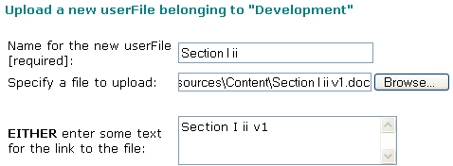

You see the main editing screen again. Now scroll down to the “userFiles for admin group Development” list again. Confirm the new file is now listed – find it and click on the ‘Add’ button.

Now move back up the page to the Bodytext of the page section. Note the new tag added corresponding to your newly loaded file (here being “<cf_userfile id=’Section I ii’ xcf>). Click on ‘Save changes’ to save and update the page. Note how the new link is placed at the end of the page.

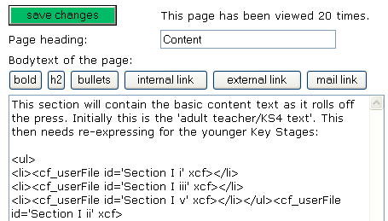

A further improvement can be to order the list, and to format the page properly. Note the existing documents have been placed in a bulleted list, as below:

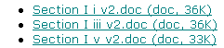

To have this ‘look’ for the new document, edit the content further to place the HTML ‘tag’ ‘<li>’ and ‘</li>’ correspondingly around the newly added tag. Note also to move the finishing ‘</ul>’ tag to the end. Furthermore, using copy and paste, the file entry can be inserted at the correct location. In this case, the content would now appear thus:

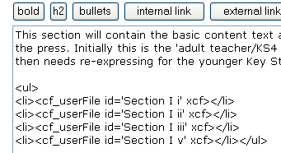

Make sure to SAVE the page again and after each edit of the page structure!! When you are happy, you can switch back to ‘Browse’ mode if you wish. That’s it! A final note could be to update the ‘blog/diary’ section to tell everyone what you’ve done.

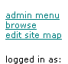

Uploading an EDITED file
Login to Soil-Net using your username and password
Navigate to ‘Development’ -> ‘Content’
Select the menu option ‘Edit’ to enter editing mode

Scroll down to the “userFiles for admin group Development” list again. Confirm the existing file is listed – find it and click on the ‘Details’ link.

A page is displayed showing first a summary of the existing file in the Soil-Net system. Note the userfile name, physical filename and link text:

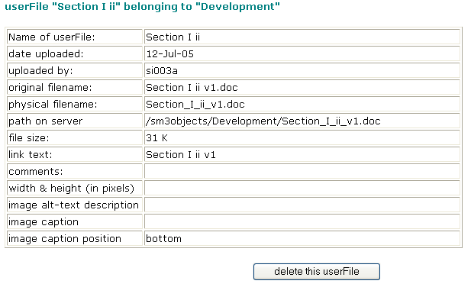

Deleting files: Note, if you wish to delete the file, there is a button to allow this. If a file is deleted, then all reference to it must also be deleted from the page content or else an error will be displayed.

Further down the page, you are given a dialogue to alter the details of the previously loaded file.

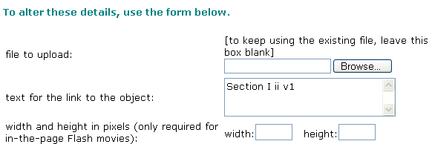

To upload the newly edited file, select ‘Browse’ to locate the new file on your hard disk.

Now edit the text for the link to the file using a name contains the version number (as this text is associated with this specific file) – e.g. “Section I ii v2”

In total there will be two entries made as below – now select ‘Save Changes’ and then ‘Back to Page Editor’.

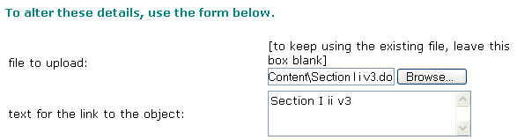

You see the main editing screen again. The page design and layout does not need editing, and the new file should be referenced by the link on the page. That’s it! A final note could be to update the ‘blog/diary’ section to tell everyone what you’ve done.

Editing textual content
You can edit the actual textual content on Site Machine too, as well as uploading reference documents. The text you edit is effectively the ‘LIVE’ text visible to the public. This is OK for a site under construction and places editorial control firmly in your hands.

Login to Soil-Net using your username and password
Navigate to the section to edit, e.g. ‘KS4’ -> ‘Introduction’
Select the menu option ‘Edit’ to enter editing mode
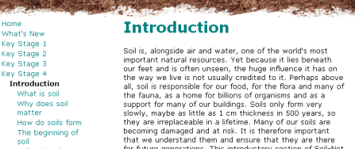
If you scroll down the page, below the initial content in ‘Edit’ mode you will see the various edit options.
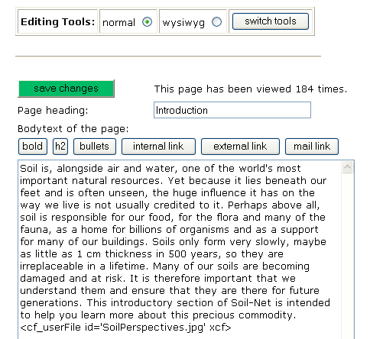

You may now simply edit and correct the text in this panel to your satisfaction, and then select the green ‘save changes’ button to save the new content.

Note, you may see entries like <cf_userFile id='SoilPerspectives.jpg' xcf>
This should not be edited as it is a reference to an image placed on the screen. See the section below for info on editing images.

Errors
You MAY see a horrible error message when you try and save the page. If this happens, the chances are you pasted in a special character from Word that the website didn’t like (this shouldn’t happen if the text is typed in directly, or pasted from Notepad). Select the browser ‘Back’ button if this happens. There is another editor you can also use which can avoid this problem – indeed you can use this ALL the time if you want. At the top of the editing section is a panel thus:


Select the ‘WYSIWYG’ button and then ‘Switch tools’. The view changes and you get an editor that looks much more like MS Word, thus:
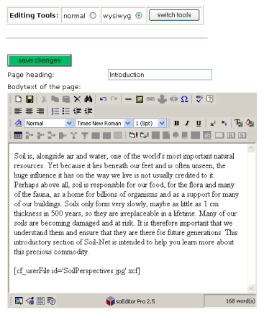

Note the icon of a disk to ‘save’ the page – or also select the green button as before. This editor should be very simple to use and allows you to add italics, bold etc. to text as you require.

Editing image labels
You can edit the labels placed next to an image.

Login to Soil-Net using your username and password
Navigate to the section to edit, e.g. ‘KS4’ -> ‘Introduction’
Select the menu option ‘Edit’ to enter editing mode

Look in the text editing panel to see the image ‘tag’ in question, such as:
<cf_userFile id='SoilPerspectives.jpg' xcf>

Note the name of the image tag in this case is ‘SoilPerspectives.jpg’ – remember this. Now scroll further down the page to see the list of images loaded into this page:

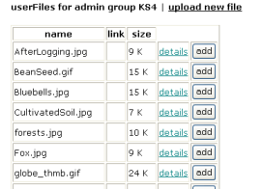

Scroll; down to find the image tag you noted earlier, and select the green text ‘details’ next to it. This brings up a page where at the top is a summary of the existing information associated with the image.
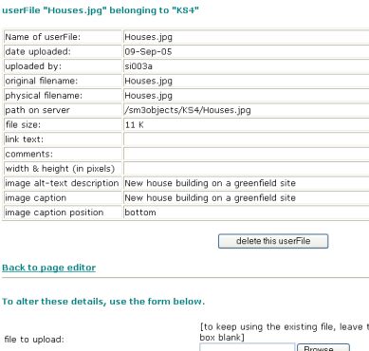

Scroll down again to the section where you can edit the details, and do so. Please REPLICATE the entry for the description and for the caption (as below). Select ‘save changes’ when complete, then the option ‘Back to Page Editor’.

