Ideas for animation on interactive experiences

The following list identifies the potential candidate themes for rich media development work.

Title: Who Lives in the Soil |  | Updated: 29/3/05
Description:
Show a 3D cutaway of the soil. Various animals will ‘appear’, popping out as the cursor passes their home. Large animals are immediately visible, smaller animals require a magnifying glass and/or the microscope tool.
Learning Objective:
Appreciation of the varied forms of life and their respective physical size.
Comment:
How many of them are there and show how deep they all live.
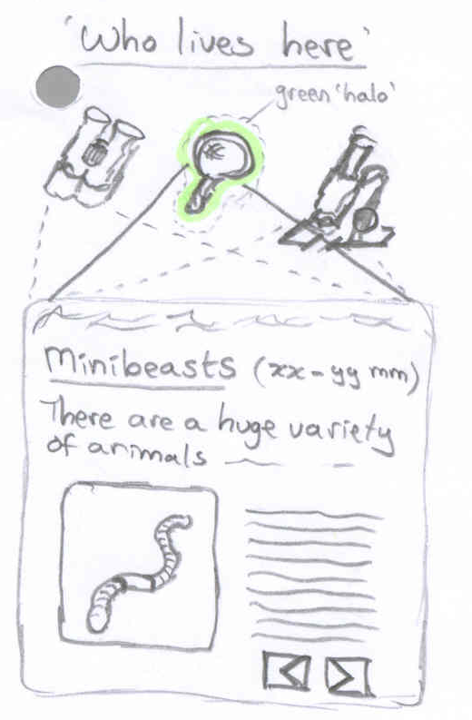

Alternatives include:
The maze. ‘Can you find your way out of the soil’? For some creatures the answer is yes and there is a pathway out (they live partly in and partly out of the soil), for some the answer is no (because they live in the soil all their life).

May be able to link this to measurement and numeracy objectives…
Application:  KS1, KS2 | Web page reference:

Title: Soil and Landscapes |  | Updated: 29/3/05
Description:
A varied landscape scene is shown – with valleys, hilltops, forest, pasture, the town etc., all composited together. The user moves cursor around this landscape, selecting where to ‘dig a soil pit’. At each pit there is a brief description of what the general soils are like ‘there’, and why that is. A couple of questions could be posed of the ‘why do you think that is?’ type…
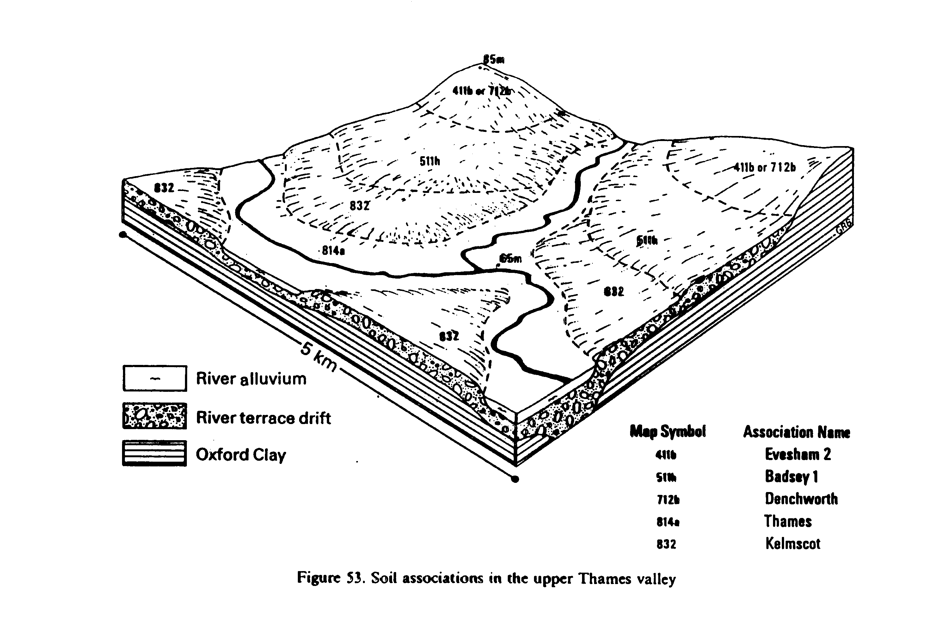
Learning Objective:
Understanding of the relationship between landscape and soil type and the way topography and land cover affect soil type.
Comment:
A soil pit and its meaning must be explained before the user can go and dig them. This could be an introductory page in the animation – or even another activity in its own right – see ‘Soil Layers’ activity.

A variety of different landscapes can be offered – mountainous, alluvial lowlands, desert, tundra etc.

Virtual soil surveyor – perhaps introduce how soil maps are created and drawn up… Draw a soil map, sort soil layers. Make easy to understand and colourful.
Application:  KS1, KS2 | Web page reference:

Title: Texture: Virtual Jam Jar experiment  PRIORITY |  | Updated: 7/4/05
Description:
Soil is added to a jar and given a good shake and left to settle. On settling (clock hands whizz by – 1 day later) several layers are now apparent in the soil representing differing fractions of soil particle sizes (sand, silt, clay, organics etc.).
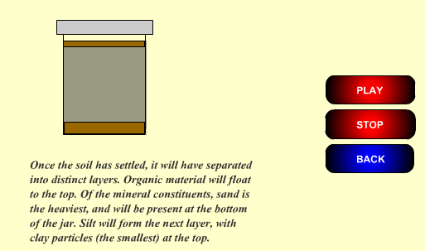
Learning Objective:
Appreciate soil physical characteristics and particle sizes.
Comment:
Student can repeat exercise with a range of differing soils, observing differences. Why are there differences?

Jam jar experiment – shake a jar and let it settle to look at particle size class (PSC) – try with different soil types from different places, e.g. a woody forest, a heath and the beach. How do they differ?

Could link to offline paper-based activities – do this yourself and compare soils near the school with your garden or allotment etc.

Make this really simple
Application:  KS1, KS2, KS3, KS4 | Web page reference:  http://www.soil-net.com/schools/jamjar/jamjar.htm

Title: Texture: Hand Texturing |  | Updated: 23/3/05
Description:
Soils are rolled into a ball etc. and differing textures inferred. May work best as a chart.
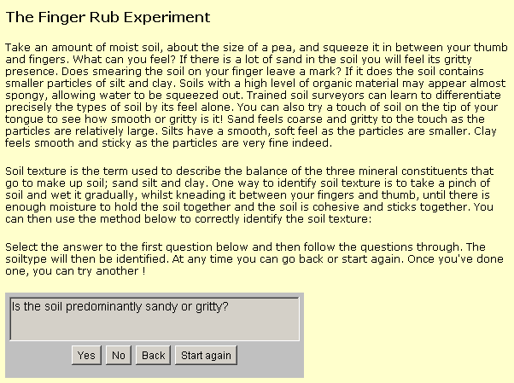
Learning Objective:
Appreciate soil physical characteristics and particle sizes.
Comment:
Student can repeat exercise with a range of differing soils, observing differences. Why are there differences? e.g. a woody forest, a heath and the beach. How do they differ?

Don’t use words like ‘predominantly’!! Simple language ‘roll into sausage’ etc.!
Application:  KS1, KS2, KS3, KS4 | Web page reference:  http://www.soil-net.com/schools/finger_rub/finger_rub.htm

Title: Soil Subsidence |  | Updated: 23/3/05
Description:
Show a house on clay soils, it hasn’t rained for ages and the trees and shrubs next to the house are VERY thirsty. Slowly the house foundations start to crack.
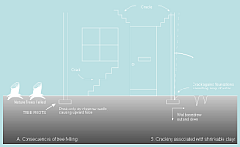
Learning Objective:
Show soil dynamics
Comment:
Student can add water, prune the tree/shrub (not chop it down though!) or change the soil e.g. to sand and observe the difference. Why is that?

Show other types of subsidence: soft soils compressibility, peat shrinkage, silt freeze heave, sand washout etc.
Application:  KS2, KS3, KS4 | Web page reference:

Title: Soil Formation  PRIORITY |  | Updated: 7/4/05
Description:
How does soil form? Weathering of rocks etc. What is soil made up of?

Learning Objective:
Show soil formation processes
Comment:
Animation of soil formation processes – weathering etc.
Application:  KS1, KS2, KS3, KS4 | Web page reference:

Title: Soil Layers |  | Updated: 23/3/05
Description:
Show cutaway of soil pit. Allow user to scrape away with trowel to expose different soil layers (horizons).
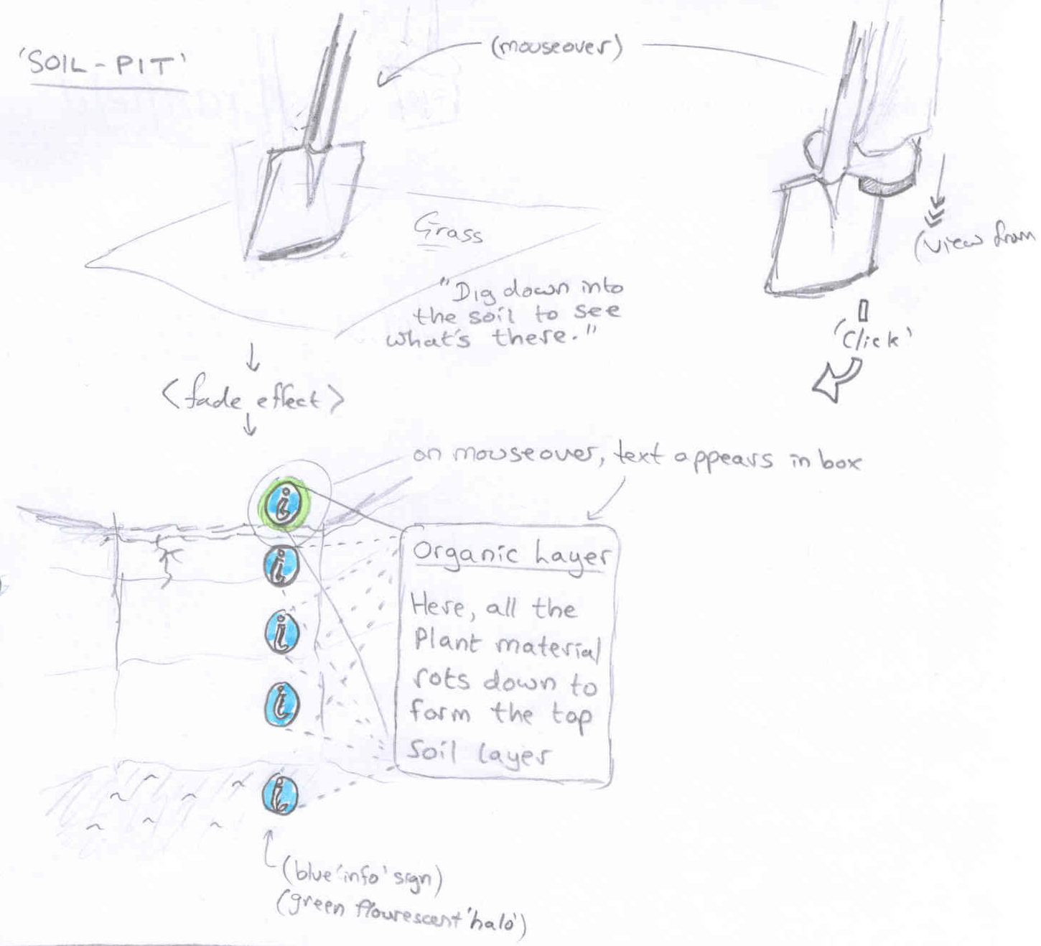
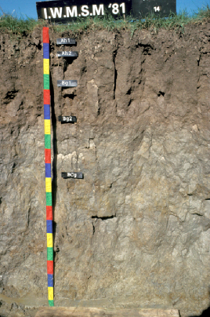
Learning Objective:
Understand soil horizons / layers
Comment:

Application:  KS1, KS2, KS3, KS4 | Web page reference:

Title: Worms and rain |  | Updated: 23/3/05
Description:
Show soil surface. Allow user to add rainfall. Worms shortly begin to appear on surface. Rain stops and worms burrow down again and worm casts begin to appear every few seconds.
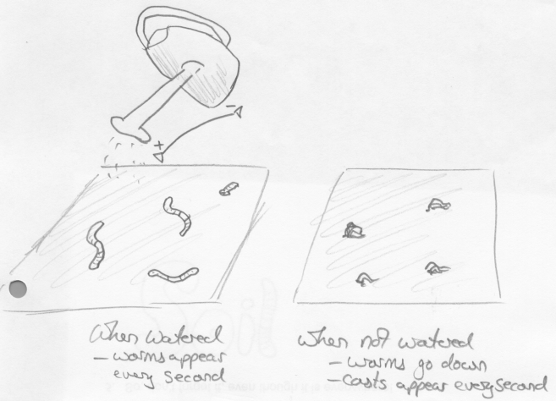
Learning Objective:
Worms habitat is underground – however they breathe air, so when it rains they must rise to the surface; their burrows become saturated. Students should appreciate that there is air beneath the ground allowing soil to serve as a habitat.
Comment:
No rain leads to casts appearing (pop, pop, pop etc.). Rainfall via a tipped watering can. Rate of rain affects rate of worm response with a slight lag each way. Rain removes the worm casts.
Application:  KS1, KS2 | Web page reference:

Title: Where do leaves go after Autumn? |  | Updated: 29/3/05
Description:
Show a deciduous tree, the leaves fall off in Autumn. Show a clock with time whizzing by as the leaves break down into the soil through actions of fungi, worms etc.
Learning Objective:
Show the biological activity in soil by speeding up time. Soil is not inert.
Comment:
Part of ‘cycles’ for younger students.
What happens if fungi are removed etc.
Time sequence passing in months
Student can control clock/time (poss. Roll back as well as forward?)
Application:  KS1, KS2 | Web page reference:

Title: Surface Run-off |  | Updated: 29/3/05
Description:
Show soil surface with rain falling. Show rain runoff flow partitioned into;

- Surface flow off – down to the river,
- Infiltration and horizontal flow within the soil - down to the river and
- Percolation, straight down into the aquifer.
- [Show also concept of efficient rain – e.g. ET]

Allow user to adjust rainfall amount and soil type (and sunshine/vegetation type?) to see partitions alter. Allow user to add differing ‘surfaces’ e.g. ‘housing estates’ ‘car parks’ ‘forest’ etc. to see rapid runoff increase and infiltration vary – why do they vary.

Learning Objective:
Show relationship between rain, soil type, land cover and soil sealing and infiltration vs. runoff. Relationship of soil within hydrological cycle. HOST?
Comment:
If all the soil is covered in concrete…half the soil…none…then what happens?
Application:  KS2, KS3, KS4 | Web page reference:

Title: Growing plants  PRIORITY |  | Updated: 7/4/05
Description:
Show a runner bean seed. Plant it and add differing soil types, differing amounts of water, sunlight and warmth. Show how changing any of these factors leads to changes in the success of germination and growth.
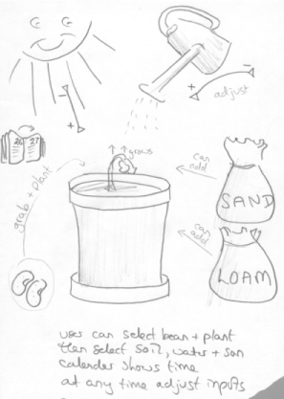
Learning Objective:
Show what effects environment has on the growth of plants.
Comment:
Link to Jack and the beanstalk? Jack is growing the ‘magic’ bean…

Sound can be used subtlety: rainfall patters, time ticks, sun sizzles, worms parp!

Alternatives include:
Showing ‘cress’ instead – problem is cress doesn’t need soil to grow!
Application:  KS1, KS2, KS3, KS4 | Web page reference:

Title: Cycles |  | Updated: 29/3/05
Description:
Show a schematic of the ‘Cycle’ in question, with a sidebar palette of options. Students can drag and drop items into their correct position on the diagram. On commencement, one item is placed correctly to start them off.
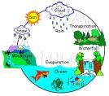
Learning Objective:
Show the elements of the cycles; oxygen, nitrogen, carbon, nutrient, hydrological, life.
Comment:
Cycles can be made more complex by Key Stage

Alternatives include:
‘Web/tree’ classification structures showing interrelationships and again user drags and drops cast objects to the ‘nodes’.
Application:  KS1, KS2, KS3, KS4 | Web page reference:

Title: Ploughing and Soil Conservation  PRIORITY |  | Updated: 7/4/05
Description:
Farmer and tractor can plough hill either a) with, or b) against contours. There may also be a field edge buffer strip. Then it rains. What happens and why?
Learning Objective:
Introduce basic soil management techniques
Comment:
Could do similar activity on slope stabilisation with geotextiles etc. Hikers on hills
Application:  KS1, KS2, KS3, (KS4) | Web page reference:

Title: Management strategy |  | Updated: 23/3/05
Description:
You are a farmer trying to get a good harvest. You must manage your resources. Make your choices and set it running for the year. At end of year review what happened, change as required and rerun.
Learning Objective:
Encourage problem solving challenges
Comment:
What-if scenarios
Application:  KS4 | Web page reference:

Title: Scientific Discovery |  | Updated: 23/3/05
Description:
You are set a challenge, e.g. How many creatures are there in the soil? Then you have to devise experimental approaches to determine the answer. A selection of potential approaches is presented and each must be evaluated and selected or discarded. This can include methods such as ‘observation’ and the ‘experimental approach’ etc. What instruments are required?
Learning Objective:
Encourage problem solving challenges
Comment:

Application:  KS2, KS3, KS4 | Web page reference:

Title: Quiz |  | Updated: 29/3/05
Description:
Simple question and answer framework with instant feedback
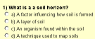
Learning Objective:
Check to see if learning process is evident – check on subjects covered earlier in Section
Comment:
Generic approach required – likely to be repeated throughout web.
Should be multiple choice – with instant feedback
Application:  KS1, KS2, KS3, KS4 | Web page reference:

Title: Match the characteristics |  | Updated: 23/3/05
Description:
A column of cast members to the left can be linked to a set of characteristics in a similar column to the right. Student selects ‘from’ and ‘to’ and is correct the line is drawn.
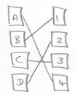
Learning Objective:
Interrelationships
Comment:
Generic approach required – likely to be repeated throughout web.

Alternatives include:
‘Drag and drop’ a cast of potential answers around a central question – the correct answer can be ‘dragged and dropped’ onto the question.
Application:  KS1, KS2, KS3, KS4 | Web page reference:

Title: Guess who I am |  | Updated: 23/3/05
Description:
User is asked a series of pre-determined questions relating to an object ‘hiding’ behind a panel. Answering correctly will successively reveal who or what it is.

Incorrect answers may be accommodated by ‘eliminating’ possible answers from a visible list for younger users.
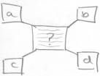
Learning Objective:
Allow student to try and guess
Comment:

Application:  KS1, KS2 | Web page reference:

Title: Hotseating |  | Updated: 23/3/05
Description:
A ‘cast’ member is called to the ‘mastermind’ chair (with spotlight) – e.g. ‘Bill’ the Badger. Student them selects from a range of predetermined questions on Bill’s lifestyle. These questions can be spoken aloud (stored mpg file) and there can then be one or more answer for each given question – again spoken aloud as required.

Alternatives include:
Two ‘cast’ members, who debate with each other.

Learning Objective:
Check to see if learning process is evident – check on subjects covered earlier in Section
Comment:
Hotseating is a common and effective technique in schools, where a person, pretending to be a character, sits on a chair and the class then ask questions about how they feel. The person must empathise with the way the character would ‘feel’ and answer in character. Here we try and repeat the exercise online.

Typical questions:
“Where do you live?”, “What do you eat?”, “What do you do in Winter?”, “Where is your toilet?” <nb. Badgers are v. interesting here!!>, “What is your bed?”, “How long do you live?”, “Do you marry?” <we don’t marry but we live together etc..>, “How many children do you have?” etc..

Need ‘cast’ actors
Application:  KS1, KS2 | Web page reference:

Title: Storytime |  | Updated: 23/3/05
Description:
Younger users are presented with a number of story narratives concerning a ‘day in the life’ of various cast members, or in life of ecosystem (wood/soil…)
Learning Objective:
Present interconnected web of relationships in easily understood form.
Comment:
Interaction of characters..
Story can be read aloud? Downloadable booklet?
Application:  KS1, KS2 | Web page reference:

Title: Spot the difference |  | Updated: 23/3/05
Description:
A pair of contrasting soil scenes are offered and the user must try to determine the differences between them.
Learning Objective:
Interrelationships. How can we manage and sustain them?
Comment:
Candidate soil landscape pairings include:
Farmed soils vs. Set-aside soils
Farmed soils vs. Golfcourse soils
Forest soils vs. Parkland soils
Soils under tarmac/pavement vs. Back garden soils
Urban soils vs. Rural soils

May allow selection of any of these for inter-comparison against any of the others.
Application:  KS1, KS2, KS3, KS4 | Web page reference:

Title: Crossword |  | Updated: 23/3/05
Description:
Crossword with clues and ‘reveal’ answer

Learning Objective:

Comment:

Typical words could include:
<Macrofauna – worm, badger, fox, rabbit, mole, vole, beetle etc.>, <Microorganism – bacteria etc.>, <elements of ecosystem>, <soil functions & threats>, <soil-related risks>, <soil components – sand, silt etc.>, <biodiversity>

Alternatives include:
Wordsearch grid
Application:  KS2, KS3, KS4 | Web page reference:

Title: Jokes |  | Updated: 23/3/05
Description:
Joke box appears. Range of appropriate soil-related jokes. Q/A.
Learning Objective:
Learn through humour!
Comment:

Knock knock: (yes these are dreadful – I know!)
Worm your way into my favour and I’ll give you a hug etc.
Badger me again and I’ll clout you etc.
Foxed me this time but next time I’ll be wiser etc.
Beetle your way through the crowd etc.
Moles on your face not underground etc.
Rabbit shaped Easter eggs

Application:  KS1, KS2, KS3, KS4 | Web page reference:

Title: Inset boxes |  | Updated: 23/3/05
Description:
Range of stylistic ‘inset’ boxes appear on the page.
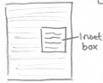
Learning Objective:

Comment:

Example topics include:
‘I never knew that!’
‘Let’s see how’
‘Soil Scientist says’
‘Quiz’
‘Soil summary’
‘Case Study’ – e.g. Brady Roman Villa, Isle of Wight

Application:  KS2, KS3, KS4 | Web page reference:

Title: Buried Archaeological Artefacts |  | Updated: 29/3/05
Description:
Show time sequence whereby an abandoned building/broach etc. gets successively buried by vegetation and wind blown soil etc.
Learning Objective:
Answer common question as to why historical artefacts/buildings etc. get buried, e.g. Brady Roman villa, Mediaeval coin hoard etc.
Comment:
Pictorial time sequence in 50-100 year steps.
Application:  KS1, KS2, KS3, KS4 | Web page reference:

Other Ideas: 07/04/05

- Plough Pans: How does a plough pan form? Show the results of successive ploughing at a fixed depth and the compaction layer building up – how can that be changed?
- Iron Pans: How and why does an iron pan form?
- pH: How can pH be measured and what does it mean?
- Ploughing: How should the farmer plough to avoid soil erosion? Is it across the hill or up and down the slope? What happens? Can buffer strips at edge of fields help?
- Restoration: How can soil be restored after industrial use, eg. a spoil tip? What problems are associated with trying to re-establish plant growth and how can soil be stabilised – geotextiles, guano/seed spray…?
- Soil analysis: The soil chemist has a sample of soil to analyse. What are the tests that can typically be done, how are they done and what do they mean?
- Soil maps: [See Soil and landscapes] How are soil maps created? How do you read a soil map?
- Soil survey: [See Soil and landscapes] Virtual soil survey of a site – the soil surveyor has arrived – what do they do next to record all the soil information.
- Soil type: [See Soil and landscapes] Does soil vary from place to place and why? How does landscape features reflect/affect soil – like slope, geology, vegetation…?
- Human/Soil interactions: Sort list of impacts/uses into good and bad impact – discussion point = why so? Examples: gardening, building, transport, waste/landfill, energy use (fuel source), pollution/contamination, football pitch, disease, farming.
- The Farm: click on parts for information – the plough, tractor, hillsplope, crops and harvest, buffer, hedge, stream… cattle poaching (erosion)

Potential Logo 23/3/05



Animated opening (max 4-5 secs) of worm crawling down over/close to the ‘t’ looking up and smiling.

General Design and Stylistic Issues 29/3/05

Need a Soil-Net Design Manual, covering issues such as;

Cues: | visual, audio, timings
Cast: | consistent naming, character and appearance
Appearance: | colour schemes, icons, layout
Typography: | font styles
Navigation: | consistency, accessibility issues
Printing - website: | CSS style guides facilitate ‘printer friendly’ page design
Printing – standalone: | print objects
Language: | Key Stage language/semantics guidance
Structural: | file/folder naming conventions

